**Exercise 1: Control Structures**  
  
**Customer and Loan table**-- Customer Table

CREATE TABLE Customer (

CustomerID NUMBER PRIMARY KEY,

Name VARCHAR2(100),

Age NUMBER,

Balance NUMBER,

IsVIP CHAR(1),

InterestRate NUMBER

);

-- Loan Table

CREATE TABLE Loan (

LoanID NUMBER PRIMARY KEY,

CustomerID NUMBER REFERENCES Customer(CustomerID),

DueDate DATE

);  
  
  
**Insert Values**

INSERT INTO Customer VALUES (1, 'Anita', 68, 13500, 'N', 7.0);

INSERT INTO Customer VALUES (2, 'David', 50, 9500, 'N', 6.2);

INSERT INTO Customer VALUES (3, 'Esha', 73, 18000, 'N', 8.5);

INSERT INTO Loan VALUES (201, 1, SYSDATE + 10);

INSERT INTO Loan VALUES (202, 2, SYSDATE + 40);

INSERT INTO Loan VALUES (203, 3, SYSDATE + 7);

COMMIT;

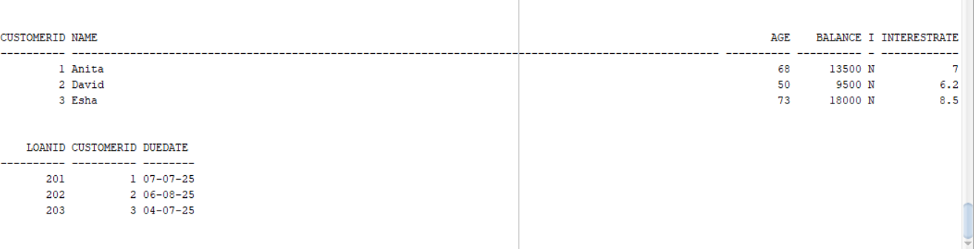  
  
  
**Scenario 1:**   
BEGIN

FOR rec IN (SELECT * FROM Customer WHERE Age > 60) LOOP

UPDATE Customer

SET InterestRate = InterestRate - 1

WHERE CustomerID = rec.CustomerID;

END LOOP;

COMMIT;

END;

**OUTPUT 1:**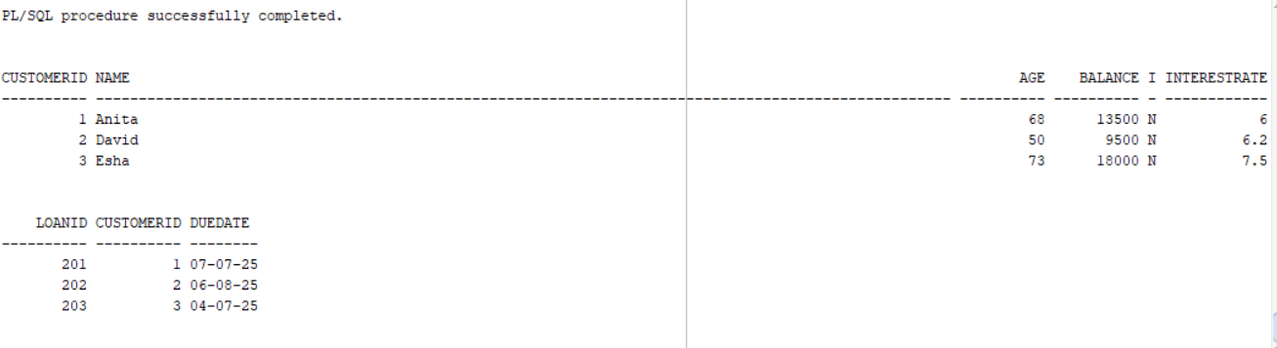

**Scenario 2:**BEGIN

FOR rec IN (SELECT * FROM Customer WHERE Balance > 10000) LOOP

UPDATE Customer

SET IsVIP = 'Y'

WHERE CustomerID = rec.CustomerID;

END LOOP;

COMMIT;

END;

**OUTPUT 2:   
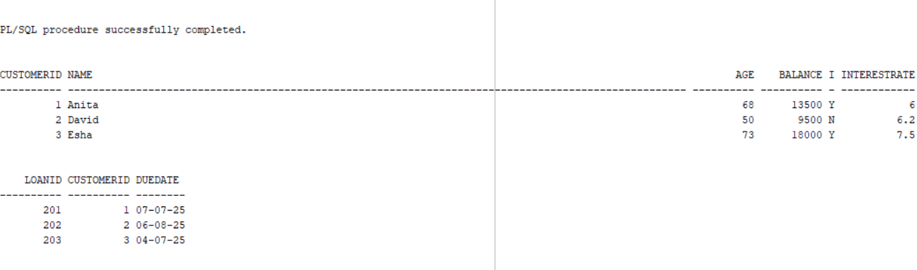  
  
Scenario 3:**   
  
BEGIN

FOR rec IN (

SELECT l.LoanID, l.DueDate, c.Name

FROM Loan l

JOIN Customer c ON l.CustomerID = c.CustomerID

WHERE l.DueDate <= SYSDATE + 30

) LOOP

DBMS_OUTPUT.PUT_LINE('Reminder: ' || rec.Name || ', your loan (ID ' || rec.LoanID || ') is due on ' || rec.DueDate);

END LOOP;

END;

**OUTPUT 3:   
